- Basic of e-Leave Module
  - Login
    - Open a [Internet Explorer] and enter e-Leave link / loading bookmark link, a login screen will show
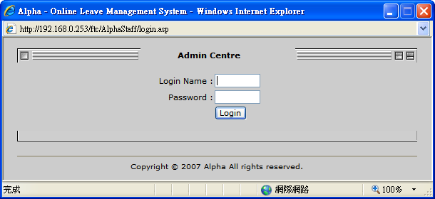

    - Enter [Login User] and [Password], then press [Login] to login
(If no login user can be use, please refer to 3.1 – 3.3)

    - If login success, below screen will show
